**AFRL Research Collaboration Program**

**Contract FA8650-13-C-5800**

**Effect of Constituents and Microstructure on Energy Dissipation Mechanisms During Damage Growth**

**University: Texas A&M University**

**REPORT COVERS PERIOD: 1-1-18 THRU 3-31-18**

1. **PROJECT TEAM MEMBERS**
2. **LEAD UNIVERSITY POC:** John Whitcomb, 979-845-4006, jdw@tamu.edu
3. **PROJECT TEAM MEMBERS:** John Whitcomb, Collin Blake
4. **AFRL TECHNICAL POC:** Craig Przybyla
5. **TECHNICAL DISCUSSION**
6. **CURRENT WORK**Development of the infrastructure to perform mesoscale analysis of 3D textile composites.

**Approach**

VTMS conducts a four-step process to generate geometric textile models. The output of each step is illustrated in Figure 1. Generally, the volume model of the tows (Figure 1.d) contains interpenetrations of the tows, which are obviously physically impossible.

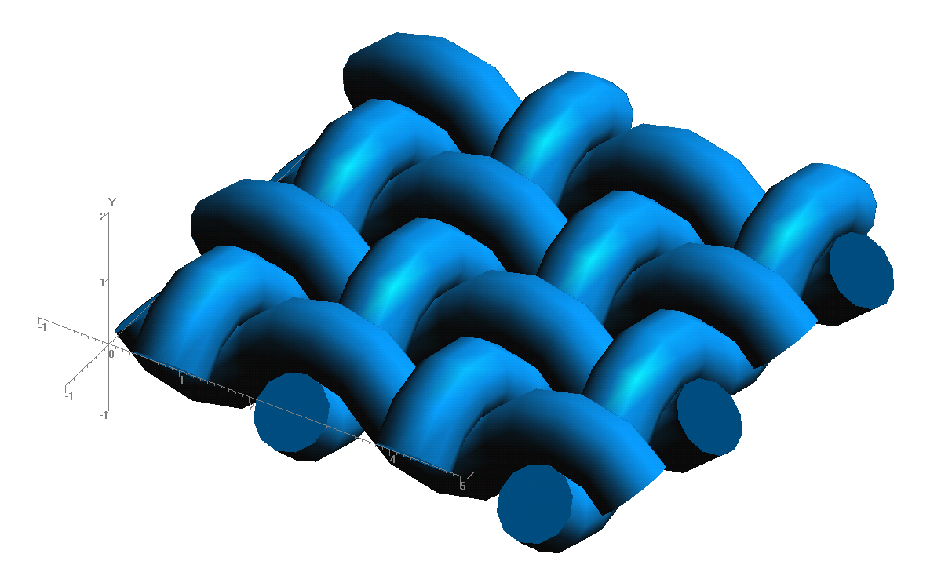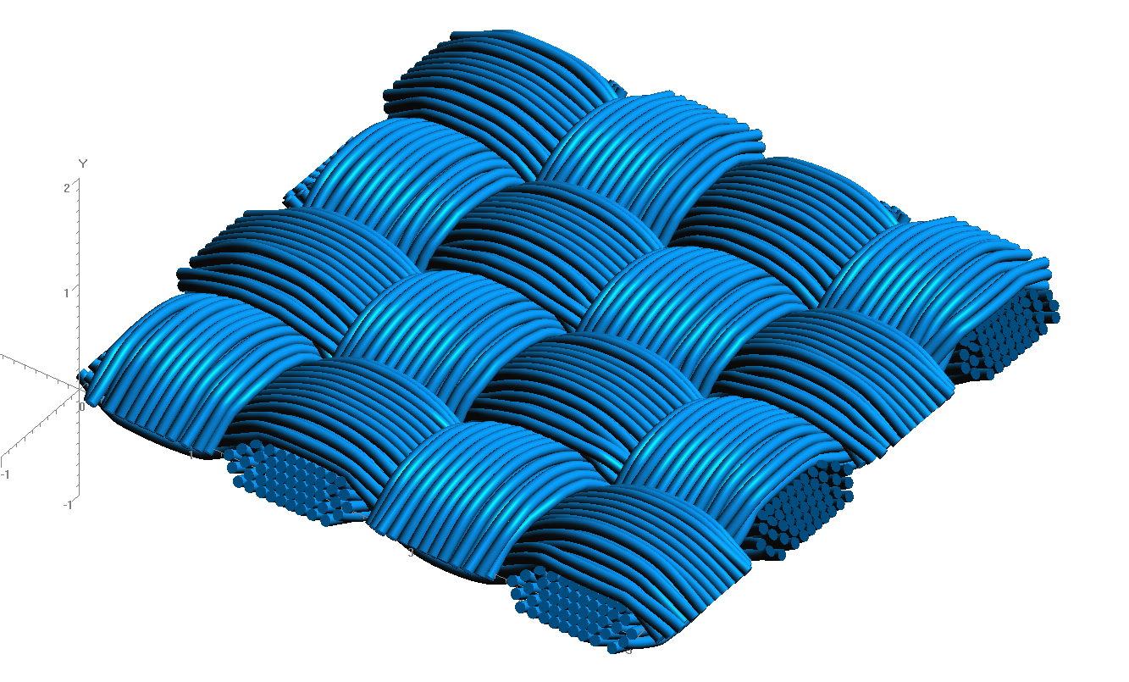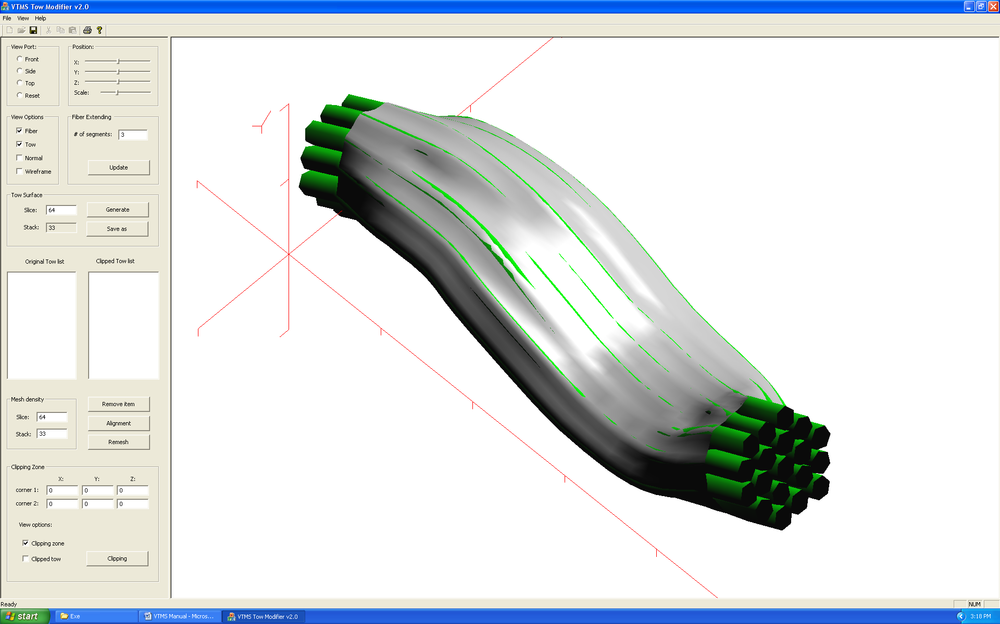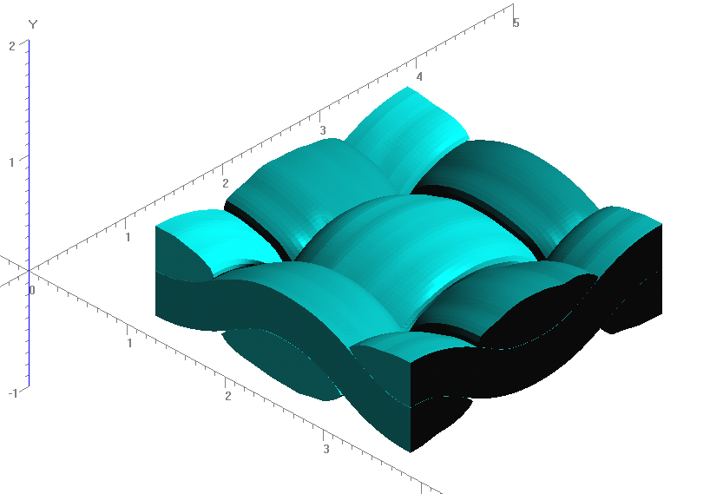

**Figure 1: Evolution of Weave Tow Geometry**

**a) Generic Approximation of Woven Pattern**

**b) Filament Representation of Pattern**

**c) Surface Approximation of Filament Bundles**

**d) Volume Model Derived from Surfaces**

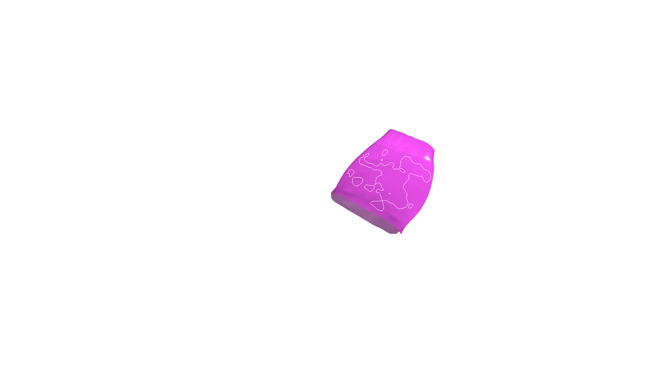The tows in Fig. 1d are actually just hollow tubes with an unusual cross-section. The interior of the tows is considered later. Figure 2 shows a representation of a series of inter-penetrations between two of these tows. Figure 2.a) shows a section of two tows in close proximity. Figure 2.b) shows how the penetrations look. Although the interpenetrations are typically small, there are multiple regions that must be fixed, since a finite element mesh cannot have such regions. The library (SISL) is a freely available library that uses NURBS to describe 3D surfaces and then identify interpenetrating regions. An interface to this library was developed and used to identify problem areas. A typical result is shown in Figure 3, which considered the tows shown in Figure 2. The arrows in Figure 3 point to the same regions of interpenetrations as in Figure 2.

**Figure 3: Surface with Penetrating Regions Outlined in White**

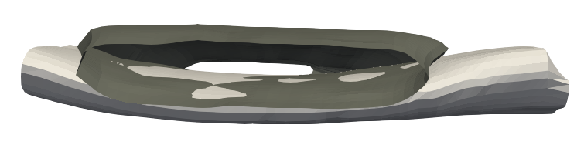

Interpenetrations

**Figure 2: Tow Surface illustration and Penetrations**

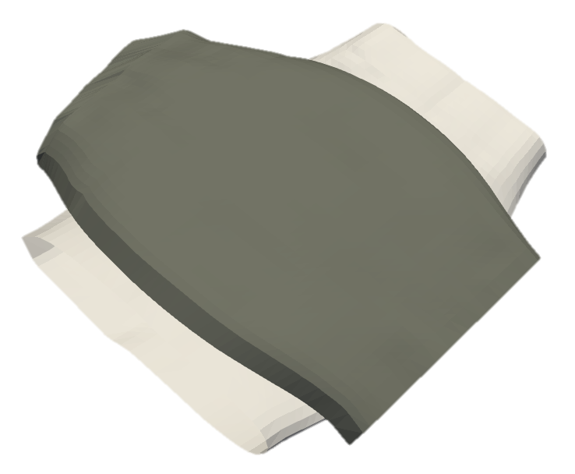

**a) Two tow surfaces in close proximity**

**b) Through view of upper tow with highlighting arrows pointing to interpenetration regions**

The regions returned from the library are described by multiple boundary curves that are not guaranteed to be unique or closed. The curves can remain open and overlap. Therefore, an algorithm was developed to test the curves against each other in order to consolidate any curves that overlap. The algorithm also removes curves that are duplicates. The impact of this step is not readily visualized, since the goal is to have the same regions identified, but with a cleaned up description of the regions.

A decision had to be made on what is needed to create a compatible mesh between the two tows where they overlap. The curve needs to have nodes where the curve itself intersects elements on the surface of each tow. Also, knowing which elements have been intersected by the interpenetration region boundary curves is useful in sub-meshing the intersected elements. The surface mesh and boundary curve interactions can be seen in Figure 4.

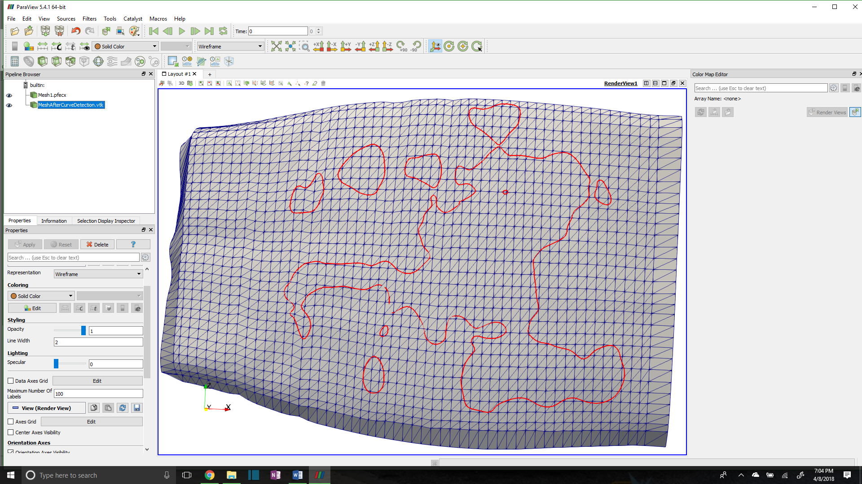

**Figure 4: Interpenetration boundary curve with tow surface mesh**

To identify which elements are intersected, and to refine the boundary curve where it intersects surface elements, the Separating Axis Theorem (SAT)**[1]** is implemented. The SAT starts by projecting the polygons onto axes. The projection can be thought of as the shadow of the polygon on an axis. The axes are created by taking the normal direction of an edge and creating an imaginary infinite line in the same direction. Figure 5 shows a projection of a triangle onto the red axis (RA) that is determined by the red edge (RE) and is parallel to the red edge normal (REN). The line segment along RA (labeled “Triangle Projection” is the projection of the triangle onto the axis RA in Figure 5. Three axes are identified, one corresponding to each side of the triangle.

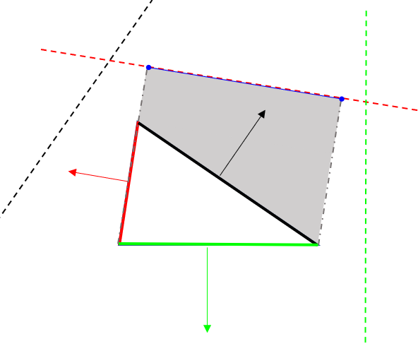

**Figure 5: Projection of a triangle on an axis**

**RA**

**REN**

**RE**

**Triangle Projection**

Next, the projections are tested to see if they overlap. If there is an axis on which the projections do not overlap, then the polygons do not intersect. If the projections overlap on every axis, then the polygons do intersect. A reference picture is shown in Figure 6.

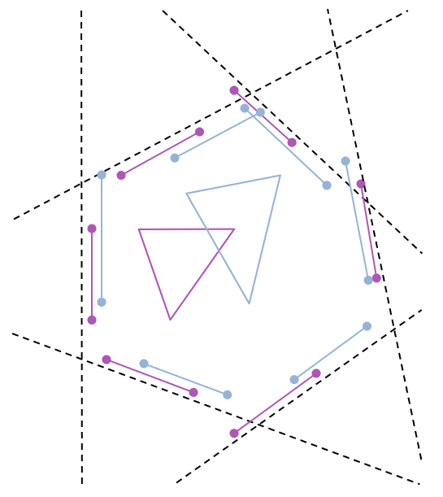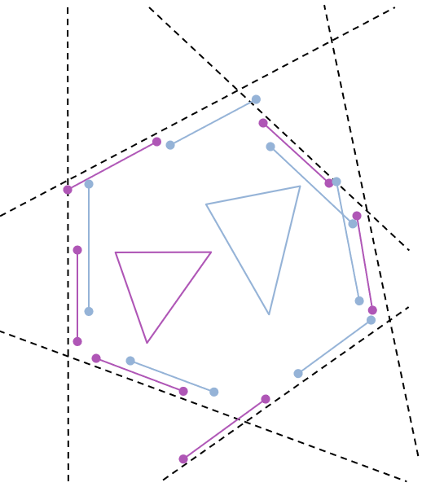

**a) SAT in which triangles overlap**

**b) SAT in which triangles do not overlap**

**Figure 6: Two cases for testing the Separating Axis Theorem**

In Figure 6.a), two triangles are shown to intersect. This can be verified by looking at each dotted line that represents a projection axis. Along each axis the bounds of the triangles are shown. There is no axis in which the bounds do not overlap. Figure 6.b) shows the case when the two shapes do not intersect. The axes (dotted lines) are the same in 6a) and 6b), since the orientations of the two triangles are the same,,, only the positioning is different. Circled are boundaries that do not overlap in 6b and therefore verify that the triangles do not intersect.

**[1] Method was found on website resource (**[**http://www.dyn4j.org/2010/01/sat/**](http://www.dyn4j.org/2010/01/sat/)**) as part of a game collision engine blog. Theory developed by Hermann Minkowski as Hyperplane Separation Theory**

Once the intersected elements are identified, we determined which boundary curve segments intersect the edge of a tow surface element, create a node at which the segment and edge intersect, and add this node to the boundary curve. An example is shown in Figure 7 where the original nodes were the endpoints of the two line segments.

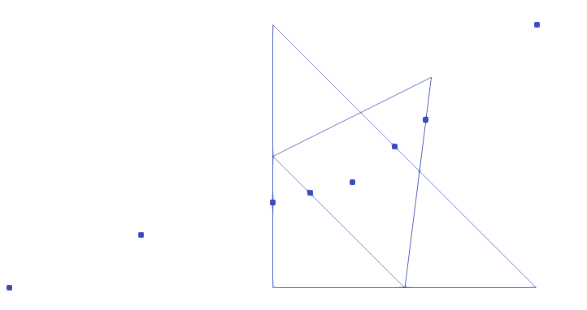

**Figure 5: Visual Representation of Separating Axis Theorem**

**Figure 7: Boundary Segments intersecting an element from each tow**

We employ this algorithm for every intersection along both tows and their elements. This results in a boundary curve that is compatible with the two surface meshes where they intersect each other. This gives the information needed to enforce compatibility between the two surfaces.

The next step it to re-mesh the elements that have been intersected so that the shape of the curve can be captured within the surface mesh of both of the tows. This requires the intersected elements identified earlier. After we sub-mesh each individual element on both tows, we can add them back to the original mesh. The result is shown in Figure 8 and 9. Figure 8 shows only one boundary curve sub-meshed and appears as a thick blue line due to the refinement of the elements around the curve. The red lines show the remaining boundary curves that have yet to be sub-meshed in this figure.

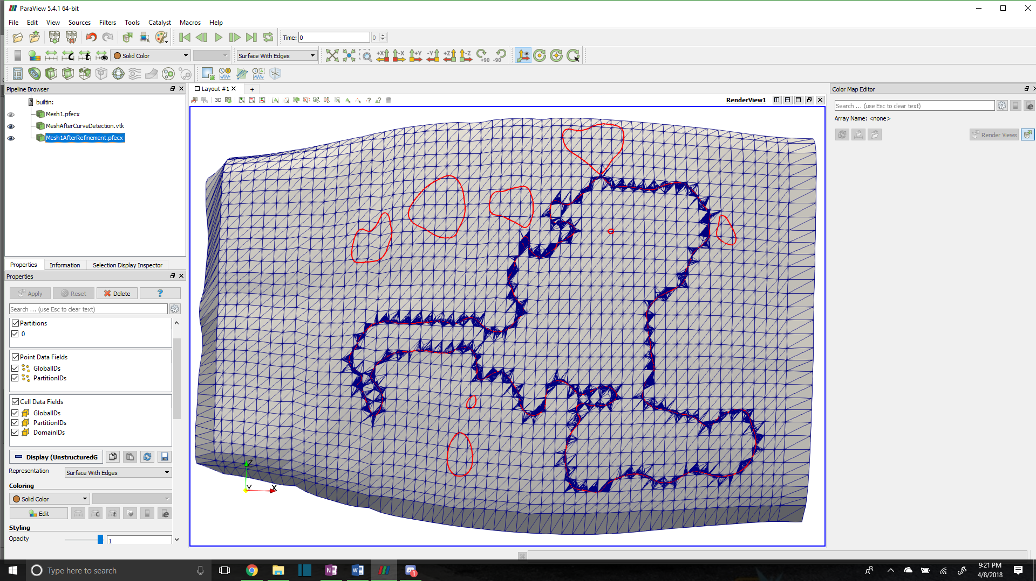

**Figure 8: Tow surface mesh with one boundary curve meshed**

Figure 9 shows some problem elements that we will attempt to solve in future work. The problem with some of these elements are their high aspect ratio. This can adversely affect an analysis in which they are used and can produce incorrect results. We currently have two plans to solve this issue. The first is to use the existing SISL library to reduce the number of nodes that are needed to describe the intricate features of the boundary curve. The second method is to record which nodes are added to the boundary curves due to intersections with surface elements and remove most of the boundary curve points that lie between any two element intersection nodes. This solution will potentially lose some of the features of the boundary curve but will ensure that the tows no longer penetrate in the boundary curve regions.

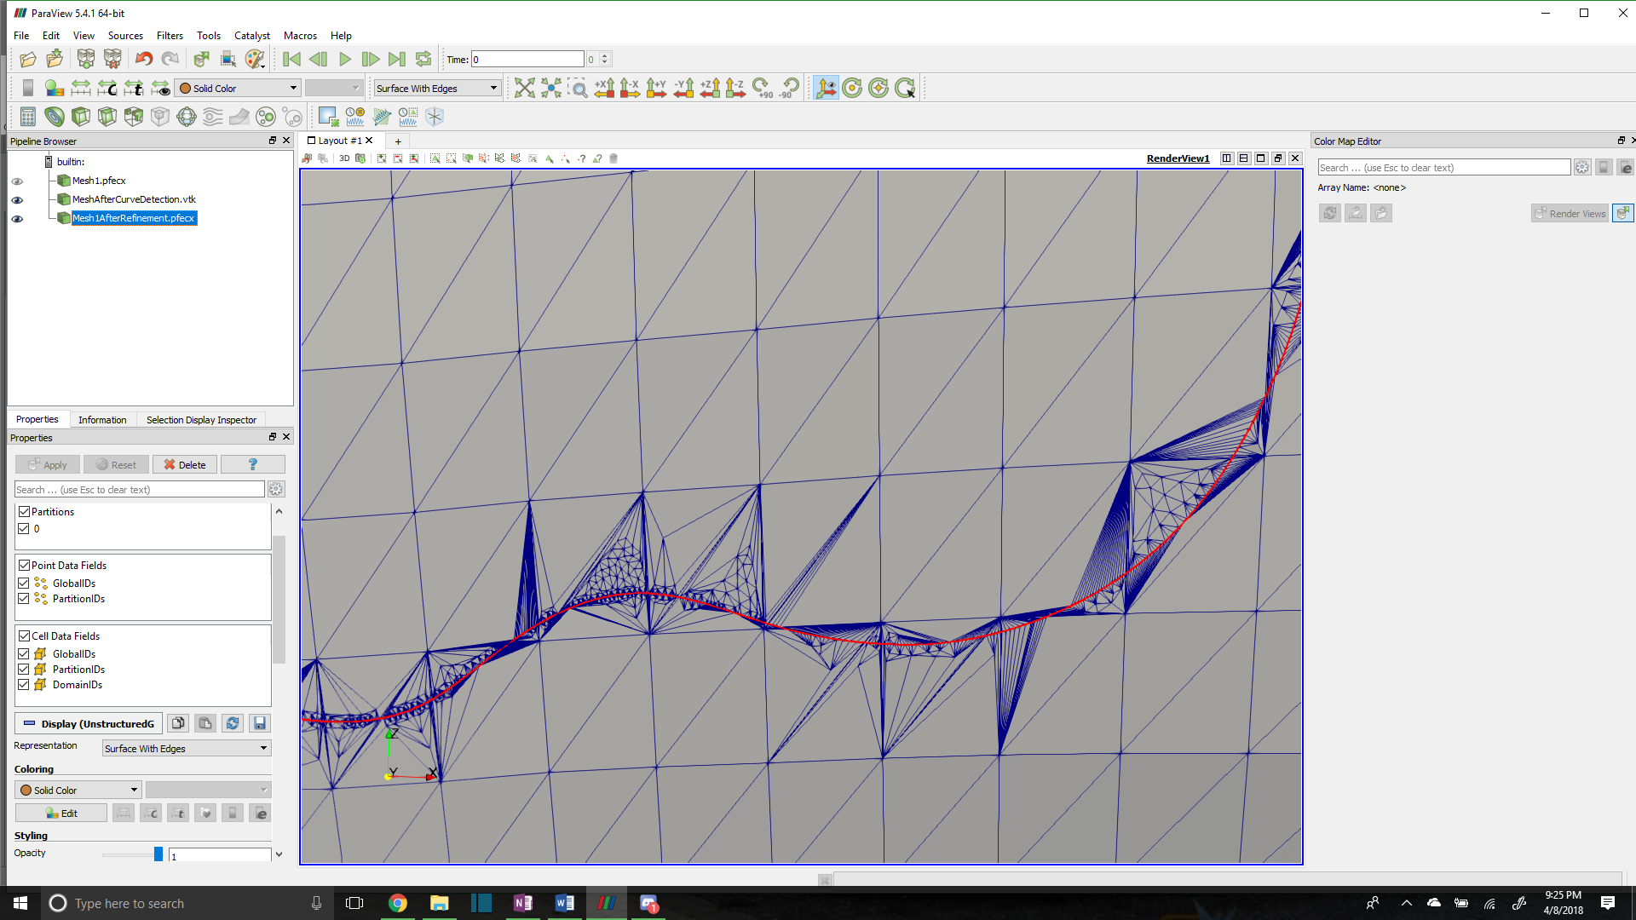

**Figure 9: Close up view of refinement**

1. **CONCLUSIONS/ANALYSIS TO DATE**

Using the boundary curve data from the SISL library, we are able to generate unique, closed curves that bound the interpenetrated region between tow surface meshes. These unique curves are used to then identify the elements on each tow that they intersect. We then add nodes where the boundary curves intersect these elements along the elements edges to ensure that there are compatible nodes for each tow surface mesh along the boundary curves. With this ensured compatibility, we then sub-mesh the curve into each tow surface mesh so that the surface meshes are compatible along the boundary curve.

1. **WORK FORECAST AND PLANS**The surface meshes with the boundary curve added to them are susceptible to very high aspect ratio elements that can adversely affect an analysis if they are used. We plan to reduce the refinement of the boundary curve, which will in turn coarsen the mesh around the boundary curve itself. The result should be a less refined boundary curve that will still describe the dominant features along the boundary curve.